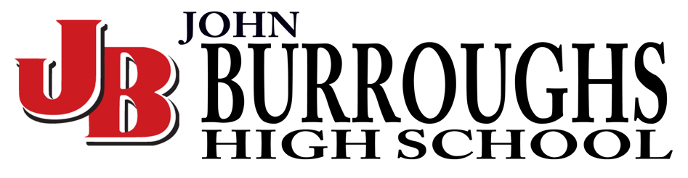
John Burroughs Comp -Executive
When: Saturday, April 9, 2022
TIme: Meet at Kennedy (By KPAC) 3:45 pm Dressed & Ready
Itinerary: 4:00 pm Leave Kennedy
5:00 pm Arrive at John Burroughs HS (Burbank)
6:30 pm Festival Starts
Awards 12:15 am
12:30 Leave
1:30 am Arrive Back at Kennedy

