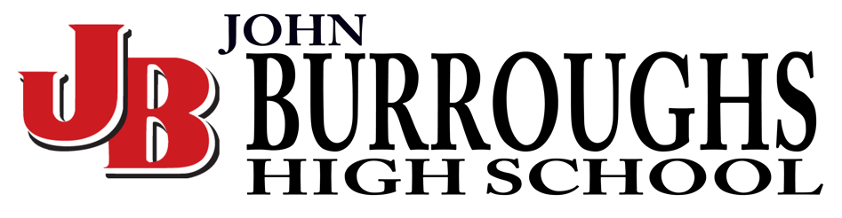
John Burroughs - Central
When: Saturday, April 9, 2022
TIme: Meet at Kennedy (By KPAC)11:15am Dressed & Ready
Itinerary: 11:15 am Meet at Kennedy
11:30 am Leave Kennedy
12:30 pm Arrive at John Burroughs HS (Burbank)
1:50 pm Festival Starts
Awards at 6:30 pm (bring lunch or lunch $$)
6:45 Pack up and Leave Oceanside
8:00 PM Arrive at Kennedy

